|  |
| --- |
| **Digital Logic Design** |
| **(EL-227)** |
| **LABORATORY MANUAL** |
| **FALL 2021** |



|  |
| --- |
| **(LAB # 3)** |
| **Implementation of Combinational Circuits** |
| **MARKS AWARDED:**  **/10** |

|  |  |  |
| --- | --- | --- |
| **LAB:** | **03** | **Implementation of Combinational circuits** |

**Objectives of the Exercise:**

1. To be able to design and implement any combinational circuit.

**Equipment Required:**

* Trainer Board (DEV-2765E)
* Logic Probe
* Digital Multimeter
* XOR gate IC (Quad 2-input, IC # 7486)
* AND gate IC (Quad 2-input, IC # 7408)
* OR gate IC (Quad 2-input, IC # 7432)

**Introduction:**

In this lab, we will design combinational circuits. A combinational circuit is a circuit whose output is dependent only on the state of its inputs.

Implement following combinational circuits on Trainer board and complete the truth tables by giving different input combinations:

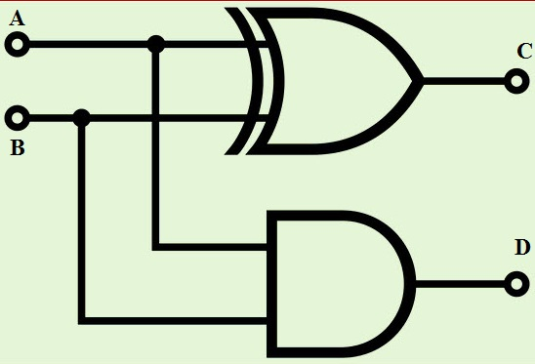**LAB Task 1:**

A) Fill in the truth table

|  |  |  |  |
| --- | --- | --- | --- |
| **A** | **B** | **C** | **D** |
|  |  |  |  |
|  |  |  |  |
|  |  |  |  |
|  |  |  |  |

B) What function the above circuit is performing ? and What does output variable C and D denote in this case ?

C) Write down the SOP and POS form for the circuit.

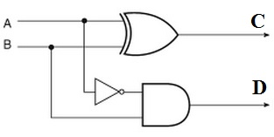**LAB Task 2:**

A) Fill in the truth table

|  |  |  |  |
| --- | --- | --- | --- |
| **A** | **B** | **C** | **D** |
|  |  |  |  |
|  |  |  |  |
|  |  |  |  |
|  |  |  |  |

B) What function the above circuit is performing ? and What does output variable C and D denote in this case ?

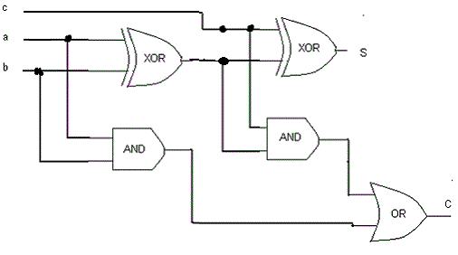

**LAB Task 3:**

A) Fill in the truth table

|  |  |  |  |  |
| --- | --- | --- | --- | --- |
| **Inputs** | | | **Outputs** | |
| **a** | **b** | **c** | **S** | **C** |
| 0 | 0 | 0 | 0 | 0 |
| 0 | 0 | 1 | 1 | 0 |
| 0 | 1 | 0 | 1 | 0 |
| 0 | 1 | 1 | 0 | 1 |
|  |  |  |  |  |
|  |  |  |  |  |
|  |  |  |  |  |
|  |  |  |  |  |

B) What function the above circuit is performing ?

C) POS and SOP

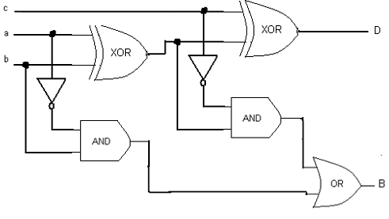**LAB Task 4:**

A) Fill in the truth table

|  |  |  |  |  |
| --- | --- | --- | --- | --- |
| **Inputs** | | | **Outputs** | |
| **a** | **b** | **c** | **D** | **B** |
|  |  |  |  |  |
|  |  |  |  |  |
|  |  |  |  |  |
|  |  |  |  |  |
|  |  |  |  |  |
|  |  |  |  |  |
|  |  |  |  |  |
|  |  |  |  |  |

B) What function the above circuit is performing ?

C)